EX NO: 3 | Configure DNS and DHCP protocols using Packet Tracer
DATE:25/7/26

Objectives:
- To configure and verify the DHCP protocol for automatic IP address allocation to client devices in a network.
- To configure and test the DNS protocol for translating domain names into IP addresses and enabling access to network resources using hostnames.

Software/Apparatus required:
  - Cisco Packet Tracer
  - End Devices (PCs)
  - Switches
  - Copper Straight-through Cable / Automatic Cable Selector
  - Routers
  - Server (DNS, HTTP and DHCP)

Procedure:
Objective 1: DHCP protocol
    - Create the required network topology using switches, a server, and PCs.
    - Connect all devices using appropriate network cables.
    - Open the server and enable the DHCP service.
    - Create a DHCP pool and specify the network parameters.
    - Configure the server with a static network address.
    - Open each PC and select DHCP in the IP Configuration settings.
    - Verify that the PCs automatically receive network configuration from the DHCP server.
    - Test communication between the PCs and the server using the ping command.
    - Save the Packet Tracer project.

Objective 2: DNS protocol

      - Create the network topology using PCs, switches, a router, a DNS server, and a web server.
      - Connect all devices using appropriate network cables.
      - Configure the router interfaces and enable communication between the networks.
      - Assign network addresses to all PCs, servers, and router interfaces.
      - Open the DNS server and enable the DNS service.
      - Create DNS records to map domain names to the web server.
      - Open the web server and enable the HTTP service.
      - Create and save the required web pages on the web server.
      - Configure the PCs with the DNS server address.
      - Open a web browser on any PC and access the website using the configured domain name.
      - Verify that the webpage is displayed correctly and test connectivity using the ping command.
      - Save the Packet Tracer project.

Diagram
Objective 1: DHCP protocol
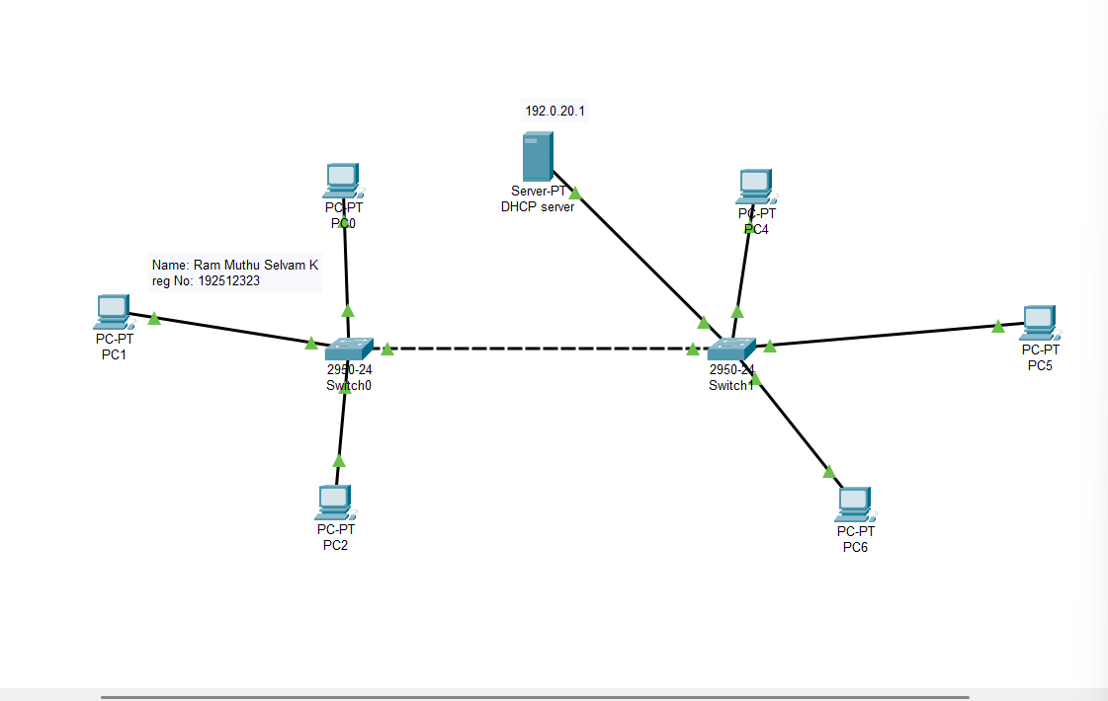

Objective 2: DNS protocol

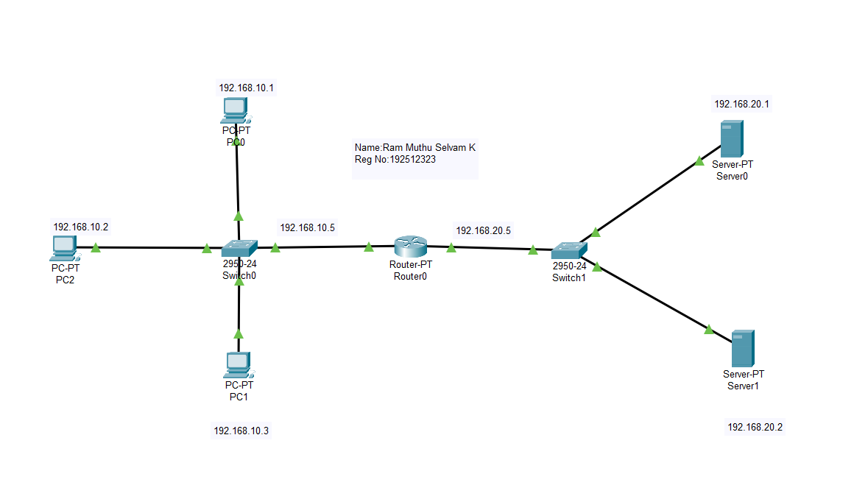

Output:

Objective 1: DHCP protocol

SI.  No | Source IP | Destination IP | Data sent (bytes) | Data received (bytes)
1. | 192.0.20.2 | 192.0.20.5 | 4 | 4
2. | 192.0.20.3 | 192.0.20.6 | 4 | 4
3. | 192.0.20.2 | 192.0.20.1 | 4 | 4
4. | 192.0.20.5 | 192.0.20.6 | 4 | 4
5. | 192.0.20.7 | 192.0.20.2 | 4 | 4

Objective 2: DNS protocol

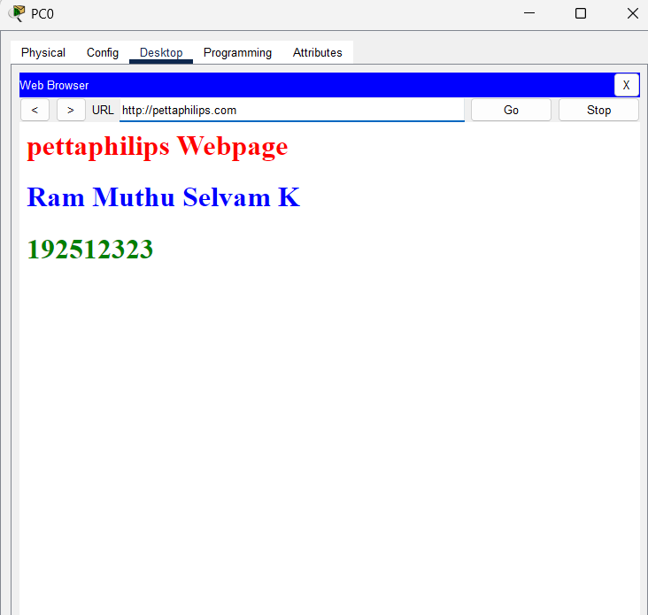

Results
Objective 1: DHCP Protocol
- The DHCP protocol was successfully configured, and the client devices automatically obtained network configuration parameters from the DHCP server.
Objective 2: DNS Protocol
- The DNS protocol was successfully configured, and the configured domain names were successfully resolved to access the web server using hostnames.

